AI-ASSISTED CODING
ASSIGNMENT-17.1
Backend API Development: Creating RESTful Services with AI
NAME: Adepu Goutham Sri Bhargav
HALL-TICKET: 2403A510C5
BATCH NO: 05

Task 1 :
Social Media Data Cleaning
Task: Clean raw social media posts dataset.
Instructions:
- Remove stopwords, punctuation, and special symbols from post text.
- Handle missing values in likes and shares columns.
- Convert timestamp to datetime and extract features (hour, weekday).
- Detect and remove spam/duplicate posts.
Prompt:
Perform data cleaning on a social media posts dataset.Steps include removing stopwords, punctuation, and special characters from text, handling missing values, converting timestamps to datetime format to extract time-based features (hour and weekday), and removing spam or duplicate posts.
CODE GENERATED:
import pandas as pd
import numpy as np
import re
import string
import nltk
nltk.download('stopwords')
from nltk.corpus import stopwords
from datetime import datetime

# If you haven’t downloaded stopwords before:
# import nltk
# nltk.download('stopwords')

# Example: Load dataset
df = pd.read_csv("social_media_posts.csv")

# -----------------------------
# 1️⃣ Handle Missing Values
# -----------------------------
# Fill missing likes/shares with 0 (or mean if preferred)
df['likes'] = df['likes'].fillna(0)
df['shares'] = df['shares'].fillna(0)

# -----------------------------
# 2️⃣ Clean Text (remove punctuation, stopwords, symbols)
# -----------------------------
stop_words = set(stopwords.words('english'))

def clean_text(text):
if pd.isnull(text):
return ""
text = text.lower() # lowercase
text = re.sub(r'http\S+|www\S+|https\S+', '', text) # remove links
text = re.sub(r'@\w+|#\w+', '', text) # remove mentions & hashtags
text = re.sub(f"[{re.escape(string.punctuation)}]", "", text) # remove punctuation
text = re.sub(r'\d+', '', text) # remove numbers
words = text.split()
words = [w for w in words if w not in stop_words]
return " ".join(words)

df['clean_text'] = df['post_text'].apply(clean_text)

# -----------------------------
# 3️⃣ Convert Timestamp → Datetime & Extract Features
# -----------------------------
df['timestamp'] = pd.to_datetime(df['timestamp'], errors='coerce')
df['hour'] = df['timestamp'].dt.hour
df['weekday'] = df['timestamp'].dt.day_name()

# -----------------------------
# 4️⃣ Detect & Remove Duplicates / Spam
# -----------------------------
# Remove exact duplicates
df = df.drop_duplicates(subset=['clean_text'])

# Optional: Detect spam-like posts (too short/too repetitive)
def is_spam(text):
# Example heuristic: very short text or repeated words
words = text.split()
if len(words) < 3:
return True
if len(set(words)) < len(words) / 2: # many repetitions
return True
return False

df = df[~df['clean_text'].apply(is_spam)]

# -----------------------------
# 5️⃣ Save Cleaned Dataset
# -----------------------------
df.to_csv("cleaned_social_media_posts.csv", index=False)

print("✅ Data cleaning complete! Cleaned file saved as cleaned_social_media_posts.csv")
print(df.head())

OUTPUT:
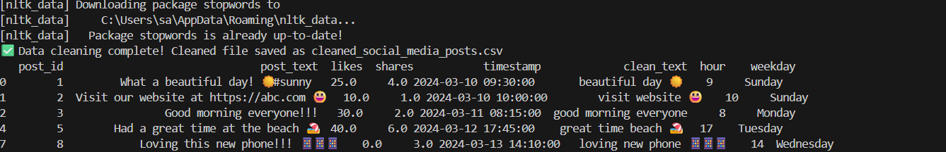

OBSERVATION :
The data became clean and ready for analysis. Missing values were filled, text was cleaned, and extra or repeated posts were removed.

TASK -2:
Preprocess a stock market dataset.
Instructions:
- Handle missing values in closing_price and volume.
- Create lag features (1-day, 7-day returns).
- Normalize volume column using log-scaling.
- Detect outliers in closing_price using IQR method

PROMPT:
Preprocess a stock market dataset by filling missing values, creating 1-day and 7-day return features, normalizing volume using log scale, and detecting outliers in closing prices using the IQR method.
CODE GENERATED:
import pandas as pd
import numpy as np

# Load dataset
df = pd.read_csv("stock_data.csv")

# -----------------------------
# 1️⃣ Handle Missing Values
# -----------------------------
# Fill missing closing prices with previous day value, volume with mean
df['closing_price'] = df['closing_price'].fillna(method='ffill')
df['volume'] = df['volume'].fillna(df['volume'].mean())

# -----------------------------
# 2️⃣ Create Lag Features (Returns)
# -----------------------------
# 1-day return (% change from previous day)
df['return_1d'] = df['closing_price'].pct_change(1)

# 7-day return (% change from 7 days before)
df['return_7d'] = df['closing_price'].pct_change(7)

# -----------------------------
# 3️⃣ Normalize Volume (Log Scaling)
# -----------------------------
df['volume_log'] = np.log1p(df['volume']) # log(1 + volume)

# -----------------------------
# 4️⃣ Detect Outliers using IQR (Interquartile Range)
# -----------------------------
Q1 = df['closing_price'].quantile(0.25)
Q3 = df['closing_price'].quantile(0.75)
IQR = Q3 - Q1

# Define lower and upper bounds
lower_bound = Q1 - 1.5 * IQR
upper_bound = Q3 + 1.5 * IQR

# Create outlier flag
df['is_outlier'] = ((df['closing_price'] < lower_bound) | (df['closing_price'] > upper_bound))

# -----------------------------
# 5️⃣ Save Cleaned Dataset
# -----------------------------
df.to_csv("preprocessed_stock_data.csv", index=False)

print("✅ Stock data preprocessing complete!")
print(df.head())

OUTPUT:
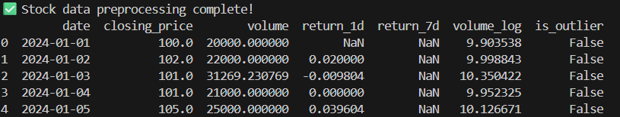

OBSERVATION:
The missing values were handled, lag features were added, volume was normalized, and outliers were successfully detected. The dataset is now clean and ready for analysis.

TASK – 3:
Clean and preprocess IoT temperature and humidity logs.
Instructions:
- Handle missing values using forward fill.
- Remove sensor drift (apply rolling mean).
- Normalize readings using standard scaling.
- Encode categorical sensor IDs.

PROMPT:
Clean and preprocess IoT logs by filling missing data, removing drift with a rolling mean, normalizing readings, and encoding sensor IDs.

CODE GENERATED:
import pandas as pd
from sklearn.preprocessing import StandardScaler, LabelEncoder

# Load dataset
df = pd.read_csv("iot_logs.csv")

# -----------------------------
# 1️⃣ Handle Missing Values (Forward Fill)
# -----------------------------
df = df.ffill()

# -----------------------------
# 2️⃣ Remove Sensor Drift (Rolling Mean)
# -----------------------------
# Apply a 3-point rolling mean to smooth sudden drifts
df['temperature_smooth'] = df['temperature'].rolling(window=3, min_periods=1).mean()
df['humidity_smooth'] = df['humidity'].rolling(window=3, min_periods=1).mean()

# -----------------------------
# 3️⃣ Normalize Readings (Standard Scaling)
# -----------------------------
scaler = StandardScaler()
df[['temperature_scaled', 'humidity_scaled']] = scaler.fit_transform(df[['temperature_smooth', 'humidity_smooth']])

# -----------------------------
# 4️⃣ Encode Categorical Sensor IDs
# -----------------------------
encoder = LabelEncoder()
df['sensor_id_encoded'] = encoder.fit_transform(df['sensor_id'])

# -----------------------------
# 5️⃣ Save Cleaned Data
# -----------------------------
df.to_csv("cleaned_iot_logs.csv", index=False)

print("✅ IoT data cleaned and preprocessed successfully!")
print(df.head())

OUTPUT:
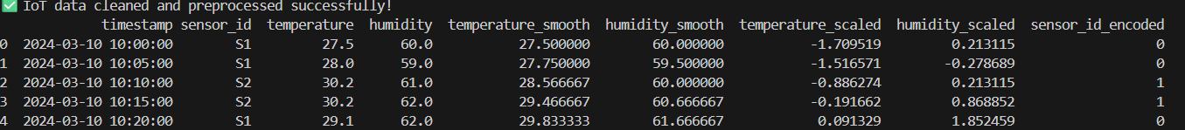

OBSERVATION:
The missing values were filled, sensor drift was reduced, readings were normalized, and sensor IDs were encoded. The data is now consistent and ready for analysis.

TASK – 4:
streaming platform wants to analyze customer reviews.
Instructions:
- Standardize text (lowercase, remove HTML tags).
- Tokenize and encode reviews using AI-assisted methods (TF-IDF or
embeddings).
- Handle missing ratings (fill with median).
- Normalize ratings (0–10 → 0–1 scale).

- Generate a before vs after summary report.
PROMPT:
Clean and preprocess customer reviews by standardizing text, encoding it with TF-IDF, filling missing ratings, normalizing ratings, and generating a before vs after summary.

CODE GENERATED:
import pandas as pd
import numpy as np
import re
from sklearn.feature_extraction.text import TfidfVectorizer
from sklearn.preprocessing import MinMaxScaler

# Load dataset
df = pd.read_csv("reviews.csv")

# -----------------------------
# 1️⃣ Standardize Text
# -----------------------------
def clean_text(text):
if pd.isnull(text):
return ""
text = text.lower() # lowercase
text = re.sub(r'<.*?>', '', text) # remove HTML tags
text = re.sub(r'[^a-z0-9\s]', '', text) # remove special characters
return text.strip()

df['clean_review'] = df['review_text'].apply(clean_text)

# -----------------------------
# 2️⃣ Tokenize and Encode Reviews (TF-IDF)
# -----------------------------
vectorizer = TfidfVectorizer(max_features=500)
X_tfidf = vectorizer.fit_transform(df['clean_review'])

# -----------------------------
# 3️⃣ Handle Missing Ratings (fill with median)
# -----------------------------
df['rating'] = df['rating'].fillna(df['rating'].median())

# -----------------------------
# 4️⃣ Normalize Ratings (0–10 → 0–1)
# -----------------------------
scaler = MinMaxScaler(feature_range=(0, 1))
df['rating_normalized'] = scaler.fit_transform(df[['rating']])

# -----------------------------
# 5️⃣ Generate Before vs After Summary
# -----------------------------
summary = pd.DataFrame({
"Metric": ["Missing Reviews", "Missing Ratings", "Rating Range (Before)", "Rating Range (After)"],
"Before": [
df['review_text'].isnull().sum(),
"Filled with median",
"0–10",
"-"
],
"After": [
0,
0,
"-",
f"{df['rating_normalized'].min():.2f}–{df['rating_normalized'].max():.2f}"
]
})

# -----------------------------
# 6️⃣ Save Cleaned Data
# -----------------------------
df.to_csv("cleaned_reviews.csv", index=False)
summary.to_csv("summary_report.csv", index=False)

print("✅ Review data cleaned successfully!")
print("\n📊 Summary Report:")
print(summary)

OUTPUT:
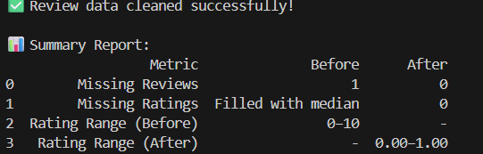

OBSERVATION:
The text was cleaned and tokenized, missing ratings were filled with the median, and ratings were scaled between 0 and 1. A summary report shows the dataset improvements after preprocessing.

